

Maze Game, by Scott Kinchlea, published by Olde Worlde Phunne is a brand-new text-based adventure game, that merges the classic old-school feel of Zork with the puzzling dungeon crawlers like The Legend of Zelda.

With a timeless, console-based user interface, the only limit is your imagination and creativity.

You can design your own mazes and share them with your friends. Will you be nice and make an easy maze? Or will you be horrible and create a monster-filled labyrinth that you will be lost in for hours?

Get lost in a maze as big or as small as you want. Fight off any demon or ghoul you can imagine. Collect the treasure that you most desire. Can you get as rich as possible before you escape?

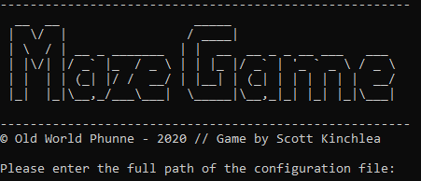

Upon starting the game, you will be greeted with a splash screen, and be prompted to enter the path of your configuration. We have provided 3 ready-made configurations at varying levels. Will you go in at easy? Or will you scower the 16 rooms and 20 passages of hard?

You will then be deposited into a random room in the maze

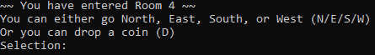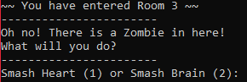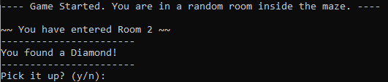

You can navigate the maze with simple inputs, or you can drop a coin to mark a room of interest.

You will find treasure in some rooms. Enter ‘y’ to pick it up, or ‘n’ to leave it.

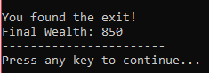

Your final goal is to find the exit. Can you collect as much wealth as you can? Challenge your friends to beat your high score!

There will be dangerous foes in some rooms. You need to figure out which attack will kill it.

Careful! It might steal some of your wealth!